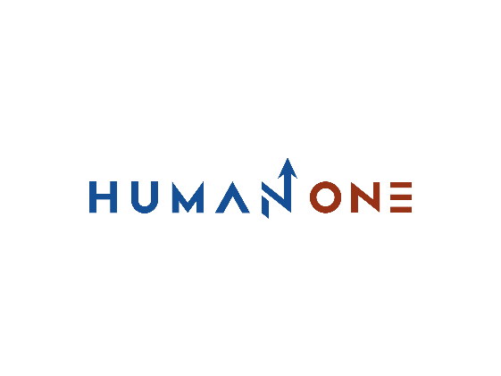

Services

Big Data & analytics

Platform Development

Expertise

**EN**

**FR**

Get in touch

Company

Cloud

Devops

Machine learning & IA

UI/UX Design

Internet Of Things

Location Based Services

Blockchain

Cybersecurity

# **Cybersecurity Consulting Services**



Our Security Center of Excellence is a team of IT security experts with a wealth of experience spanning across multiple technology domains and industries. We apply our cybersecurity consulting services and extensive knowledge of security best practices and standards to ensure that our clients’ mission-critical systems are reliably protected from all known and emerging threats. With our cybersecurity consulting services, we help our clients stay safe and ready for the digitalized future.

Let’s Talk

** Security assessment**

We test embedded code, applications, networks, and hardware components for vulnerabilities. We conduct security assessment using various methods and at all levels: from penetration testing of web services and mobile apps to fuzz testing and reverse engineering of on-prem applications

The Security Center of Excellence was formed to strengthen HumanOne position as a cybersecurity consulting company. We offer our cybersecurity advisory & consulting services as a response to the rapidly growing number of security-related requests and the rising concern about the lack of intrinsic security in many enterprise-grade systems working with sensitive financial, medical, and private data. Today, this unit is involved in the majority of the company’s production processes, but also acts as a standalone department offering a wide range of services to our clients that choose HumanOne among so many cybersecurity consulting companies.

## **Our cybersecurity consulting services**

**Compliance audit**

We analyze our clients’ IT landscape and check it for compliance with the most important industrial security standards, such as ISO 27001, NIST 80-53, HIPA, GDPR, and CCPA. We have devised an end-to-end approach for compliance checks to ensure the highest level of accuracy and predictability of results



**SDLC compliance**

The most secure systems are typically built in strict compliance with the SDLC process, where adequate time and effort is allocated to testing and quality assurance at each production stage. We help companies adjust their development processes to focus more on quality and intrinsic security

**Configuration/system audit**

We perform full-scale penetration testing of isolated computer systems or entire networks. We identify issues in system configuration files, Active Directory settings, network permissions, database security, and key elements of a company’s IT infrastructure

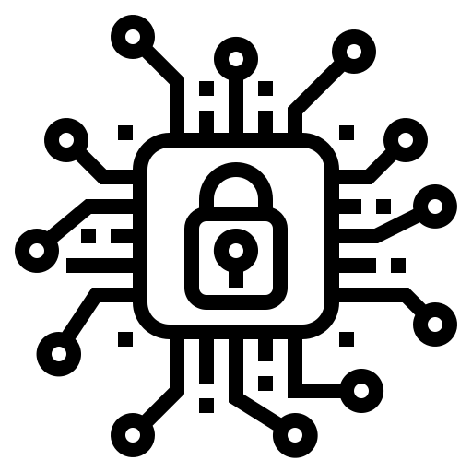**Security awareness**

We help companies raise security awareness among developers, testers, and end users by highlighting the most important security-related aspects of their work. Our cybersecurity advisory & consulting services include how-to’s for every role involved in the day-to-day operation of IT systems of all types

**Business continuity planning**

Today’s companies can’t survive without a business continuity plan in case of emergencies. As a cybersecurity consulting company, we help our clients achieve their goals by expertly assessing their readiness for crisis situations and proposing disaster recovery guidelinessilos.

**Long-term risk mitigation**

We help companies address security concerns even before the start of a software development project by assessing its overall architecture. HumanOne cybersecurity consulting means that we help reduce the cost of incidents, minimize downtime, and facilitate long-term product maintenance

Want to secure your business from the IT perspective?

Get in touch

**Compliance at all levels**

Our cybersecurity consulting services not only help identify and apply the best tools and methods for data protection, but also ensure maximum compliance with the most stringent security standards.

As a cybersecurity consulting company, we scrupulously analyze our clients’ systems, assess them from various standpoints, perform penetration testing, and document the results in great detail. These conclusions can then be used for adapting the systems to existing or future security standards to ensure their stable operation. Our cybersecurity consulting allows companies reach global standards of cyber resilience.

**Regular security audits**

Our managed security services enable any organization concerned with the protection of their own and their clients’ data and systems to keep IT security at a consistently high level.

This can be achieved through regular security audits at all levels. We stand out among cybersecurity consulting companies, because our specialists ensure that any changes to the system are fully in line with established security policies and guidelines. Whenever a particular security standard is modified, we help evaluate the system-wide impact of this change and update the affected components

**Long-term risk mitigation**

## **Benefits of our cybersecurity advisory & consulting services**

Cybersecurity consulting services from Intellias keep our clients protected from intrusion attempts, data leaks, identity theft, and other threats that can jeopardize the work of a company in the long run.

HumanOne helps maintain security to produce a long-term risk mitigation plan and revisiting it on a regular basis. From security patches and process optimization to on-site security training — we’ve got it all covered within the scope of our cybersecurity consulting services. Our holistic approach to data security and cybersecurity consulting gives our clients the much-needed confidence in a successful tomorrow.

